Anti- Uroplakin 1B Antibody
MSVA-734M / Mouse monoclonal

Human SwissProt | O75841
Human Gene Symbol | UPK1B
Synonyms | Tetraspanin-20; Tspan-20; TSPAN20; UP1b; UPIb; UPK1B; Uroplakin-1b
Specificity | Uroplakin 1B
Immunogen | Recombinant fragment of human UPK1B protein
Isotype | Mouse / IgG
Species Reactivity | Human
Localization | Cell Surface
Storage & Stability | Antibody with azide – store at 2 to 8 C. Antibody without azide – store at -20 to -80 C. Antibody is stable for 24 months. Non-hazardous. No MSD required.
Supplied As | 200ug/ml of Ab Purified from Bioreactor Concentrate by Protein A/G. Prepared in 10mM PBS with 0.05% BSA & 0.05% azide. Also available without BSA
Positive Control | Urinary bladder: A strong membranous and cytoplasmic UPK1b immunostaining should be seen in the urothelium (the staining can be limited to the top cell layers or equally involve all cell layers).
Negative Control | Colon: UPK1b immunostaining should be absent in all cells of the colon mucosa.

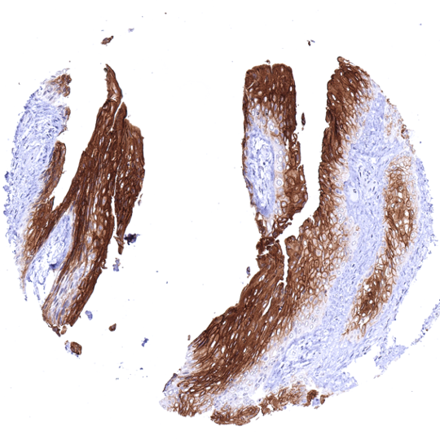
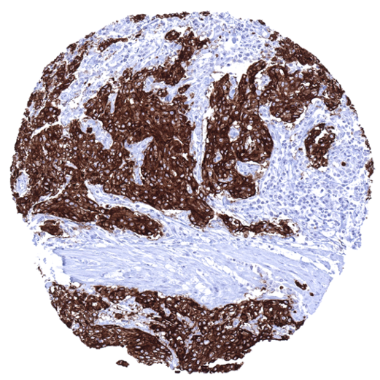
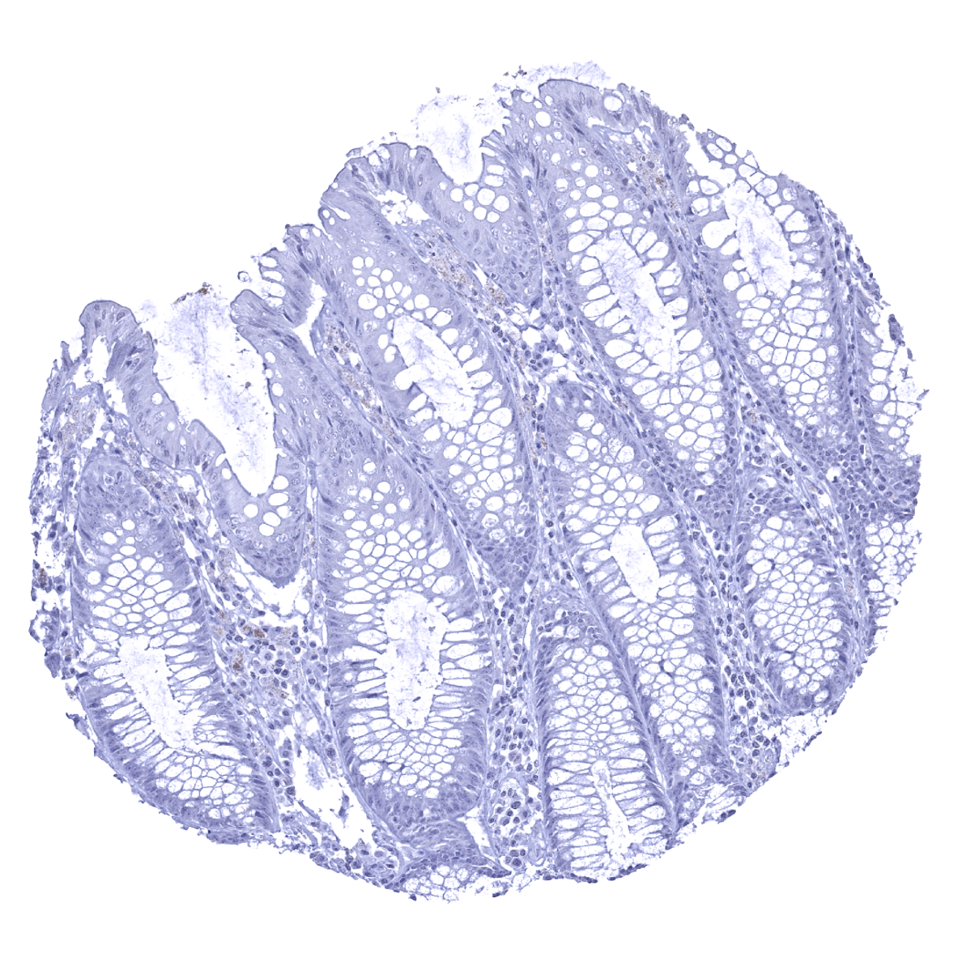
Colon descendes, mucosa - UPK1b immunostaining is absent in all cells of the colon mucosa.
A strong UPK1b immunostaining of all suprabasal urothelial cells is seen in this urinary bladder sample.
Muscle-invasive urothelial carcinoma of the urinary bladder showing a strong Upk1b immunostaining of tumor cells.

Biology
Uroplakin 1B (Upk1b), is a 29,6 kDa protein which is encoded by the UPK1B gene located at 3q13.3-q21. Upk1b is one out of 5 known uroplakin (Upk) protein particles that cooperatively form apical asymmetrical unit membrane (AUM) plaques which play an important role in the stabilization and strengthening of epithelial cells that line the bladder. These AUM plaques enable the inner bladder membrane to stretch and prevent urothelial cells from rupturing during bladder distension. AUMs and Upk proteins may also have a role in mediating membrane permeability and signal transduction events that are relevant for the regulation of cell development, activation, growth, and motility. In normal tissues, a strong membranous and cytoplasmic UPK1b immunostaining occurs in the urothelium where the staining can be limited to the top cell layers or equally involve all cell layers. UPK1b immunostaining is variable in squamous epithelium. A moderate to strong UPK1 positivity is regularly seen in a fraction of cells of the respiratory epithelium, amnion and chorion cells of the placenta, gallbladder epithelium and intrahepatic bile ducts, some endocervical and endometrial glands, a fraction of cells in the fallopian tube, intercalated ducts and a fraction of large excretory ducts of the pancreas, superficial epithelial cells and parietal cells of the stomach, the parietal layer of Bowman capsule in the kidney, and the superficial layer of anal transitional epithelium. The TCGA database on RNA expression in cancer has described upregulation of Upk1b in a fraction of urothelial, head and neck, lung, endometrial, cervical, ovarian and renal cancers.
Potential Research Applications
-The prevalence and clinical significance of Upk1b expression in cancer is unknown.

Protocol Suggestions
Dilution: 1:150 ; pH 7,8 is optimal. Freshly cut sections should be used (more than 10 days between cutting and staining deteriorates staining intensity for most antibodies in IHC).

Limitations
This antibody is available for research use only and is not approved for use in diagnostics.

Warranty
There are no warranties, expressed or implied, which extend beyond this description. MSVA is not liable for any personal injury or economic loss resulting from this product.

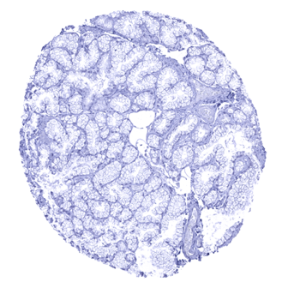
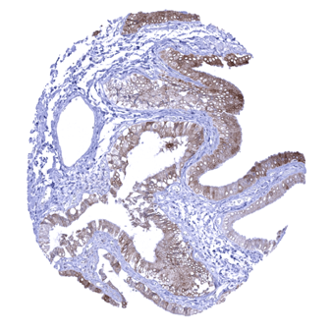
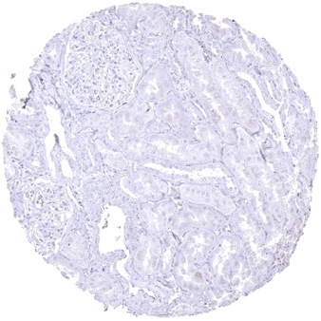
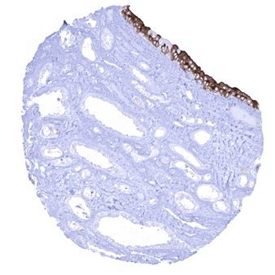
Duodenum, Brunner gland
Gallbladder, epithelium - A weak to moderate cytoplasmic and membranous UPK1b immunostaining is seen in the gallbladder epithelium.
Kidney, cortex - In the kidney, a weak to moderate UPK1b immunostaining is seen in the parietal layer of the Bowman capsule.
Kidney, pelvis (urothelium) - Most urothelial cells in the renal pelvis show a strong UPK1b immunostaining

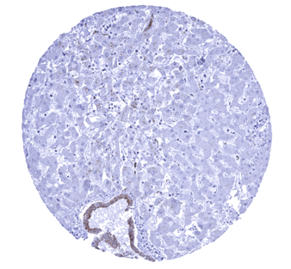
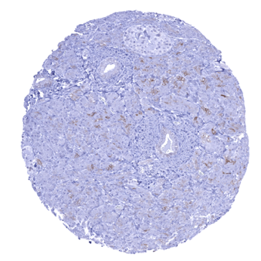
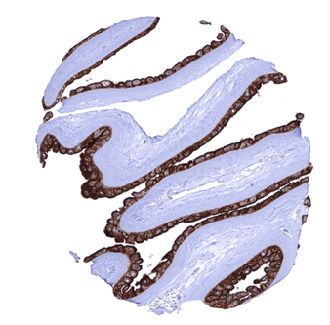
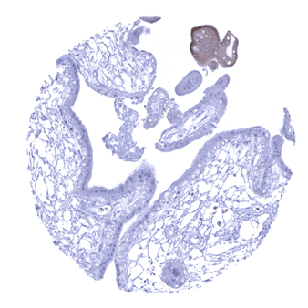
Liver - A moderate cytoplasmic and membranous UPK1b immunostaining is seen in intrahepatic bile ducts
Pancreas - In the pancreas, a weak to moderate UPK1b immunostaining of intercalated ducts is seen
Placenta (amnion and chorion) - Strong UPK1b immunostaining in amnion cells of the placenta
Placenta, early - A weak to moderate UPK1b immunostaining can be found in a fraction of syncytiotrophoblasts of the placenta

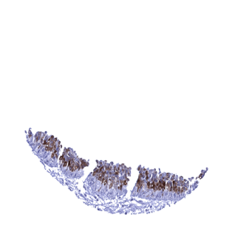
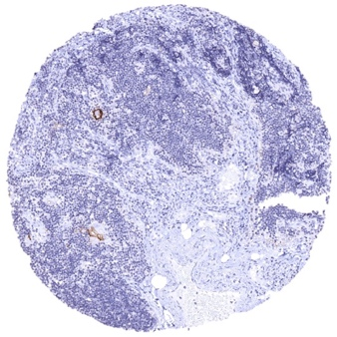
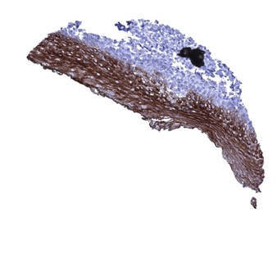
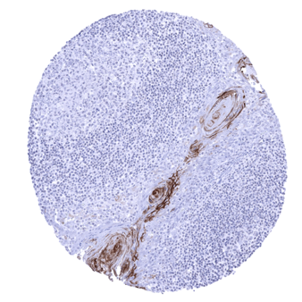
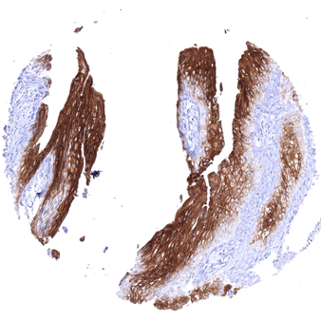
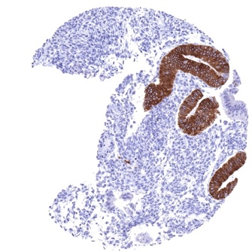
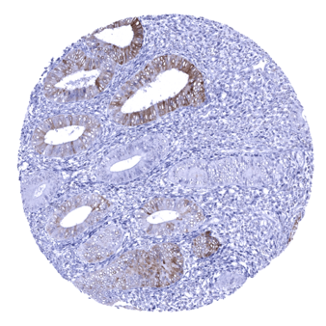
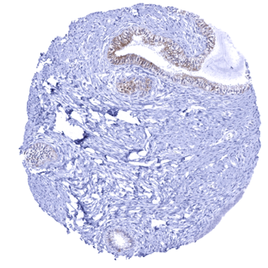
Sinus paranasales - A fraction of respiratory epithelium cells (mostly goblet cells) show a moderate to strong UPK1b immunostaining
Thymus - Some layers of corpuscles of Hassal’s show a moderate to strong UPK1b positivity in the thymus
Tonsil - Some layers of tonsil crypt epithelium showa moderate to strong UPK1b immunostaining
Tonsil, surface epithelium - A strong UPK1b immunostaining is seen in the top 2_3 of the non-keratinizing squamous epithelium lining the tonsil surface
Urinary bladder, urothelium - A strong UPK1b immunostaining of all urothelial cells is seen in this urinary bladder sample
Uterus, endometrium- Strong Upk1b staining of some glands while others are completely negative
Uterus, endocervix - In this sample, endocervical epithelial cells show a weak to moderate UPK1b positivity
Uterus, endometrium (proliferation) - A weak to moderate UPK1b immunostaining is seen in a fraction of endometrial glands

