Anti-Synaptophysin Antibody
MSVA-462R / Recombinant Rabbit monoclonal

Human SwissProt | P08247
Human Gene Symbol | MSH2
Synonyms | Major synaptic vesicle protein p38; MRX96; MRXSYP; Syn p38; Syp; SYPH
Specificity | Synaptophysin
Immunogen | Recombinant fragment of human Synaptophysin protein
Isotype | Rabbit / IgG
Species Reactivity | Human
Localization | Cytoplasmic
Storage & Stability | Antibody with azide - store at 2 to 8°C. Antibody without azide - store at -20 to -80°C.Antibody is stable for 24 months. Non-hazardous. No MSD required.
Supplied As | Purified antibody in Tris pH 7,3-7,7 with 1% BSA, <0,1% NaN3. Also available WITHOUT BSA & azide at 1,0mg/ml.
Positive Control | In the colon, a moderate to strong staining of the axons of the Auerbach’s and Meissner’s plexus should be seen while the endocrine cells of the mucosa and the peripheral nerves in the mucosa must show an at least a weak to moderate staining. In the pancreas, a strong staining should be seen in islets of Langerhans and in peripheral nerve fibres located between the exocrine cells.
Negative Control | In the colon, all non-endocrine epithelial cells and lymphocytes should not show any staining.

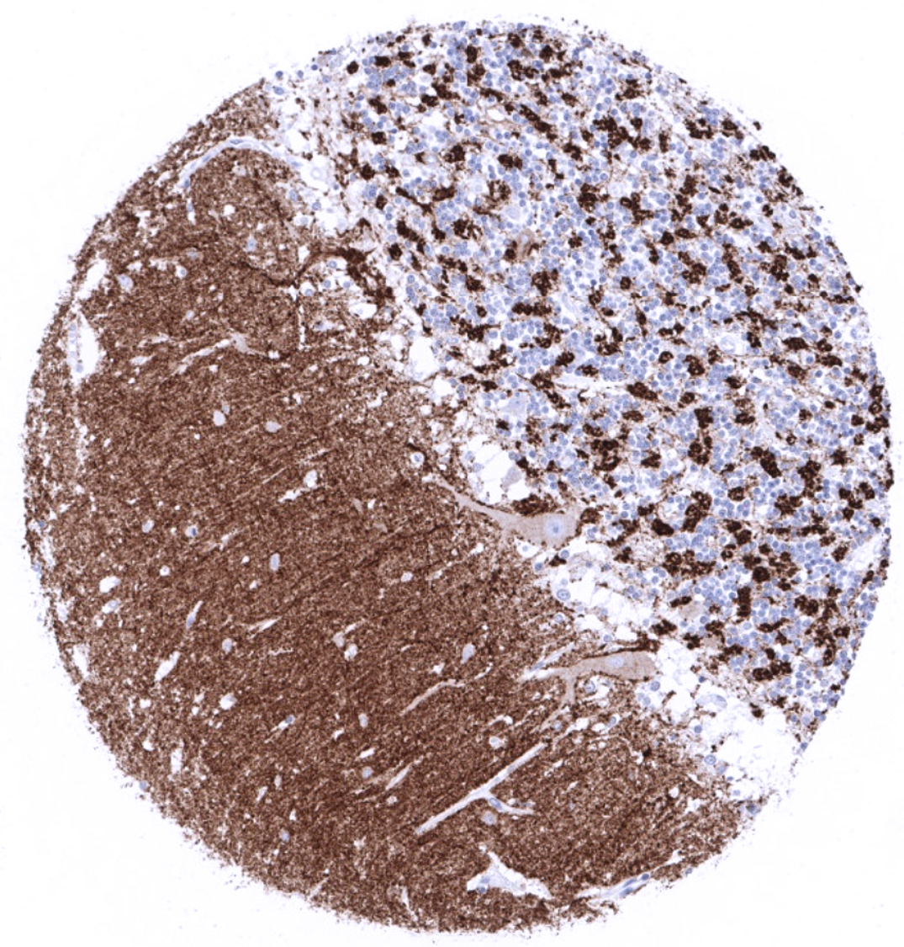
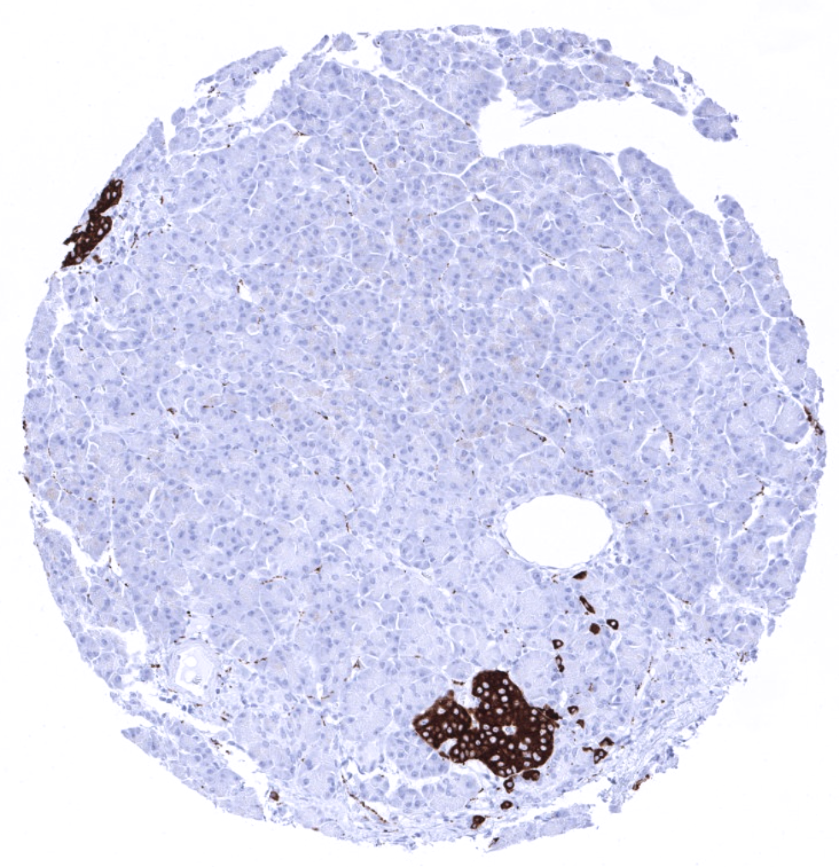
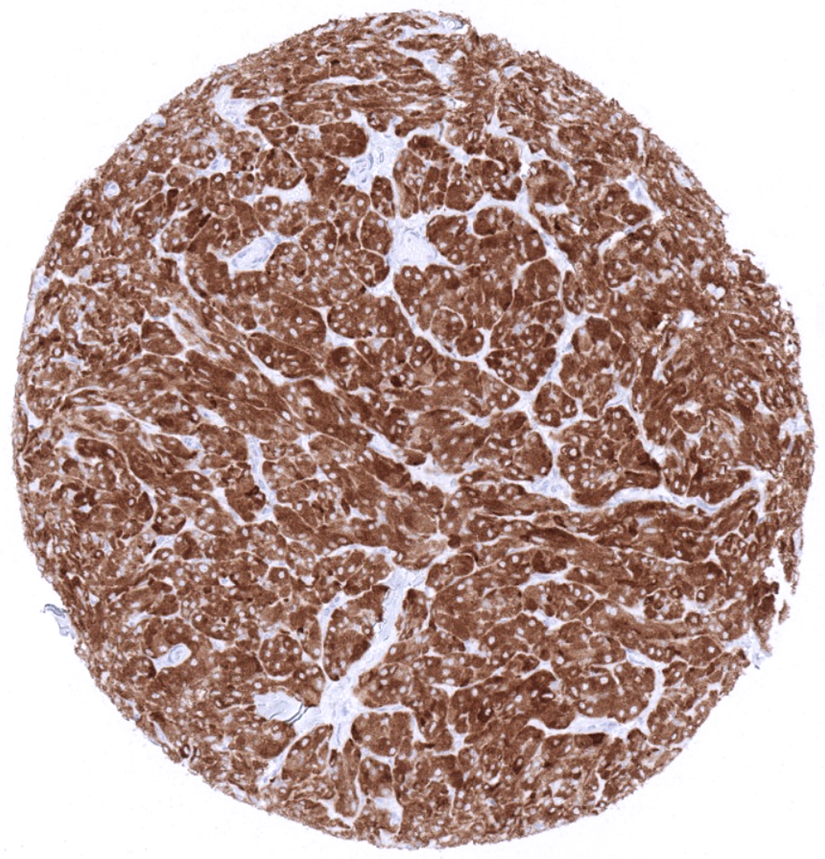
Synaptophysin immunostaining in the molecular, Purkinje and granular layers of the cerebellum.
In the pancreas, synaptophysin immunostaining is seen in islets of Langerhans and delicate nerve fibres intermingled between acinar cells.
Medullary thyroid carcinoma with strong diffuse synaptophysin immunostaining.

Biology
Synaptophysin is a commonly used marker for neuroendocrine differentiation. It is a 38kDa calcium binding integral-membrane glycoprotein protein coded by the SYP gene located at Xp11.23-p11.22. It is also termed as “major synaptic vesicle protein p38” reflecting the fact, that it is the most abundant synaptic vesicle membrane glycoprotein, present in neuronal presynaptic vesicles. It is present in virtually all neurons in the brain and spinal cord and it is also regularly expressed in neuroendocrine cells of all kinds. In normal tissues, synaptophysin is found to be strongly expressed in cerebrum (grey matter), cerebellum (molecular, Purkinje, and granular layer), islets of Langerhans of the pancreas, the medulla of the adrenal gland, the anterior lobe of the pituitary gland (adenohypophysis), and in scattered cells of the diffuse neuroendocrine system, which are especially seen in the gastrointestinal epithelium (including Brunner glands), respiratory system, and endocervical epithelium. A weak to strong immunostaining occurs in axons and ganglion cells of the peripheral nerves in the gastrointestinal wall. Synaptophysin staining can also be seen in adrenal cortical cells, goblet cells (mostly in the small intestine) and Paneth cells. In tumors, synaptophysin is typically expressed at high levels in pheochromocytoma, neuroendocrine tumors, neuroendocrine carcinomas, medullary carcinomas of the thyroid, pituitary adenomas, Merkel cell carcinomas and in small cell carcinomas irrespective of their site of origin. Synaptophysin is also seen in various neuronal tumors such as neuroblastoma, ganglioneuroblastoma, ganglioneuroma, and ganglioglioma. Synaptophysin may also be detected in brain tumors like oligodendroglioma, astrocytoma and ependymoma, however, to a varying extent. Moreover, synaptophysin can be detected in a small fraction of various other tumor entities, such as for example breast, prostate or ovarian cancers if these tumors exhibit neuroendocrine differentiation.

Potential Research Applications
-The clinical significance of neuroendocrine differentiation of cancers not originating from neuroendocrine precursor cells is still not clear. This especially applies for its prognostic and therapeutic implications.
-Synaptophysin interacts with the essential synaptic vesicle protein synaptobrevin but its exact function is not known.
-Because of its ubiquity at the synapse, synaptophysin quantification by immunostaining is used for quantification of synapses.

Protocol Suggestions
Dilution: 1:100. pH9 is optimal Freshly cut sections should be used (more than 10 days between cutting and staining deteriorates staining intensity for most antibodies in IHC).

Limitations
This antibody is available for research use only and is not approved for use in diagnostics.
Not for resale without express authorization.

Warranty
There are no warranties, expressed or implied, which extend beyond this description. MSVA is not liable for any personal injury or economic loss resulting from this product.
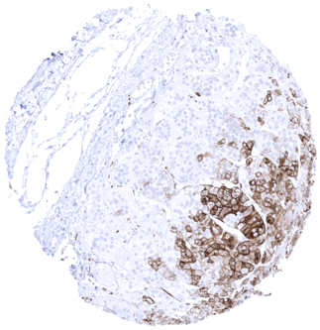
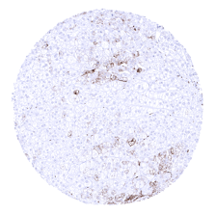
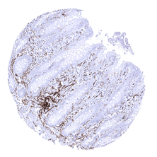
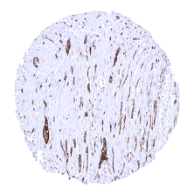
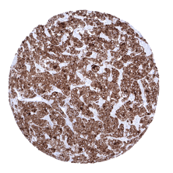
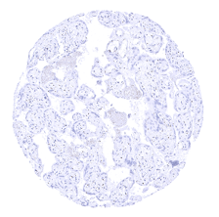
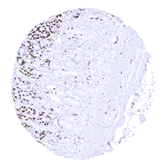
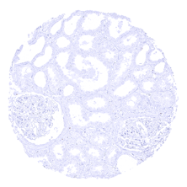
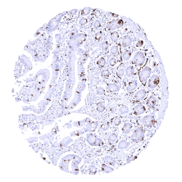
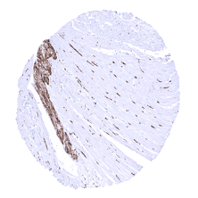
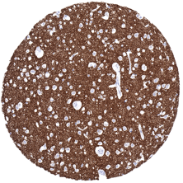

Appendix, muscular wall
Adrenal gland- A weak to moderate synaptophysin immunostaining can be found in a subset of cells of the adrenal cortex
Appendix, mucosa- In the appendix, synaptophysin immunostaining is limited to neuroendocrine cells and nerve fibres
Adrenal gland- A strong synaptophysin immunostaining regularly occurs in the medulla of the adrenal gland. Some cortical cells may show weak to moderate staining
Stomach, antrum
Placenta, mature
Pituitary, anterior lobe- Strong synaptophysin immunostaining in all epithelial cells of the adenohypophysis
Pituitary gland, posterior lobe- Strong synaptophysin immunostaining in the neurohypophysis
Pancreas- A strong synaptophysin immunostaining is seen in islet cells of Langerhans
Lymph node
Kidney, cortex
Duodenum, mucosa- In the small intestine, synaptophysin immunostaining is seen in neuroendocrine cells and in goblet cells
Colon descendens, muscular wall
Cerebrum, grey- Synaptophysin is strongly expressed in cerebrum (grey matter)
Cerebellum (molecular, granular and Purkinje layers_ white matter) - Synaptophysin is strongly expressed in cerebellum (molecular, Purkinje, and granular layer)

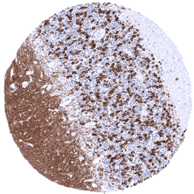

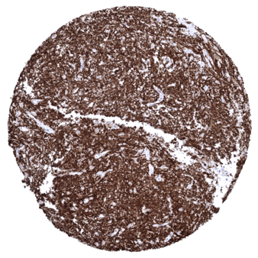
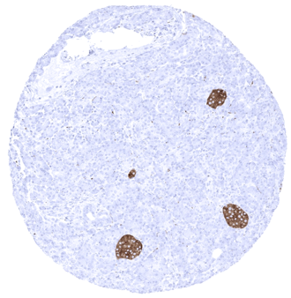
Ileum, mucosa- In the small intestine, synaptophysin immunostaining is seen in neuroendocrine cells and in goblet cells

