Anti- PLAP Antibody
MSVA-350R / Recombinant Rabbit monoclonal

Human SwissProt | P05187
Human Gene Symbol | ALPP
Synonyms | Alkaline phosphatase placental type; Alkaline phosphatase Regan Isozyme; ALP; Alp1; ALPP; Germ-cell alkaline phosphatase; nagao Isozyme; PALP; Placental alkaline phosphatase 1; placental heat-stable alkaline phosphatase; PLAP-1; PLAP1
Specificity | PLAP
Immunogen | Recombinant human ALPP protein
Isotype | Rabbit / IgG
Species Reactivity | Human
Localization | Cell Surface and Cytoplasmic
Storage & Stability | Antibody with azide – store at 2 to 8 C. Antibody without azide – store at -20 to -80 C. Antibody is stable for 24 months. Non-hazardous. No MSD required.
Supplied As | 200ug/ml of Ab Purified from Bioreactor Concentrate by Protein A/G. Prepared in 10mM PBS with 0.05% BSA & 0.05% azide. Also available without BSA
Positive Control | In the placenta, a strong membranous and cytoplasmic staining of cytotrophoblasts and syncytiotrophoblasts must be seen, while staining is absent or minimal in stromal cells.
Negative Control | Normal testis: PLAP staining must be absent in normal germ cells of all types. In the appendix no structures/cells should show any PLAP staining.

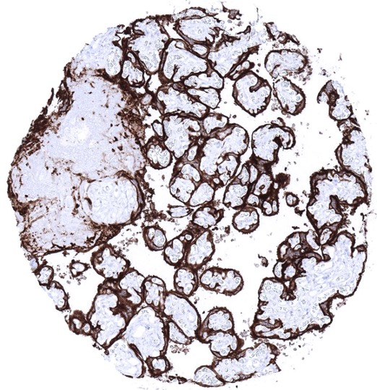
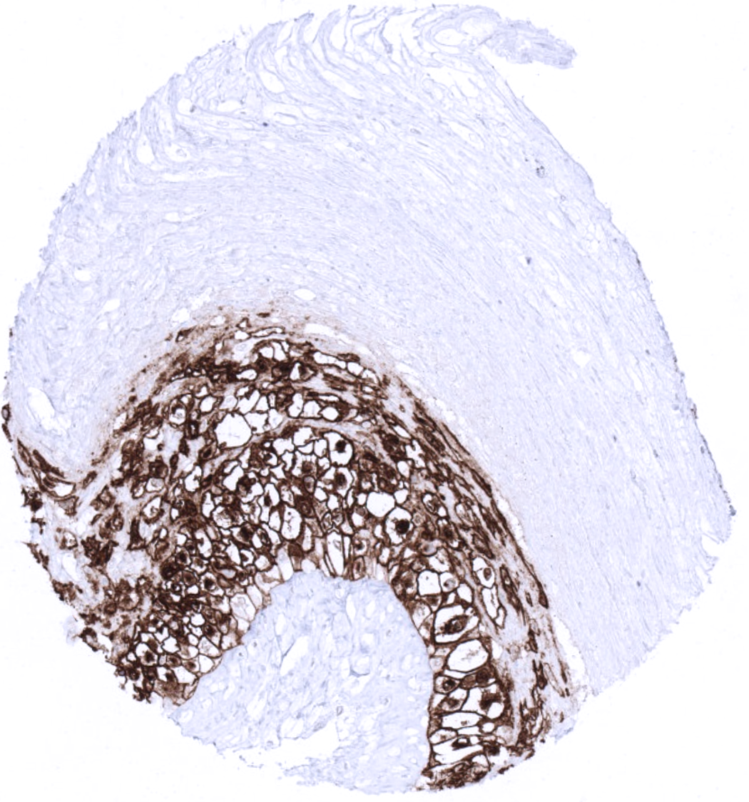
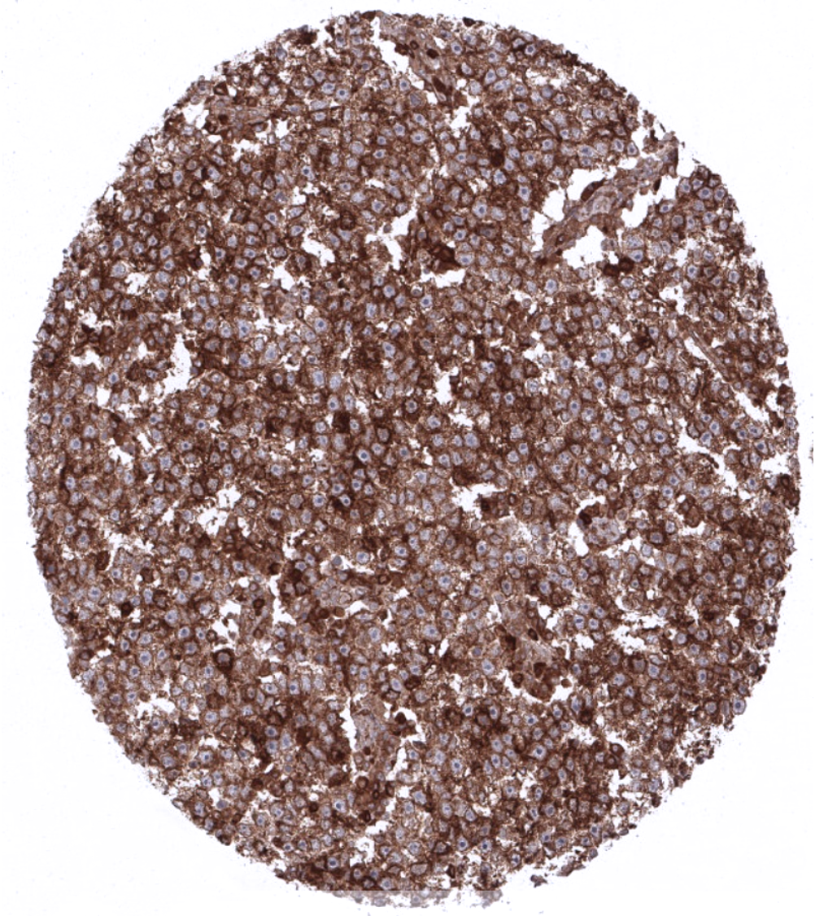
Strong PLAP immunostaining in all trophoblastic cells of a mature placenta.
Placenta tissue showing strong PLAP immunostaining in chorion cells.
Strong PLAP immunostaining in all cells of a testicular seminoma.

Biology
Placental alkaline phosphatase (PLAP), also known as alkaline phosphatase, placental type is encoded by the ALPP gene at 2q37.1. PLAP is a dimer of 65 kDa consisting of 530 amino acids and is thought to play a role in guiding migratory cells and transport specific molecules over the plasma membrane. PLAP is expressed in placenta from the 8th week of gestation and the concentration increases continually throughout the pregnancy. PLAP can be separated into three distinct isoenzymes corresponding to early, mid and term placenta. Using antibody VA109, PLAP immunostaining is almost entirely limited to the placenta. Here, a particularly strong staining is seen in chorion cells as well as in cyto- and syncytio-trophoblast of mature placenta. Staining is only moderate and limited to the surface cell membrane in the trophoblast of early placenta, and only weak in amnion cells. A weak PLAP staining can also be seen at the surface apical membrane in endocervix, endometrium, and the fallopian tube, but this is not seen in all samples analyzed. Using MSVA-xxx, PLAP immunostaining is lacking in all other normal tissues. In tumors, PLAP is consistently expressed at high levels in seminoma, dysgerminoma, germinoma, intratubular germ cell neoplasia, and hydatidiform moles. PLAP is - usually at lower levels - also often positive in embryonal carcinoma, yolk sack carcinomas, and choriocarcinoma. PLAP is usually absent in spermatocytic seminoma.

Potential Research Applications
-As the literature is partly conflicting, the diagnostic utility of PLAP expression analysis should be investigated in a large cohort of tumors from different entities.

Protocol Suggestions
Dilution: 1:150 ; pH9 is optimal. Freshly cut sections should be used (more than 10 days between cutting and staining deteriorates staining intensity for most antibodies in IHC).

Limitations
This antibody is available for research use only and is not approved for use in diagnostics.

Warranty
There are no warranties, expressed or implied, which extend beyond this description. MSVA is not liable for any personal injury or economic loss resulting from this product.

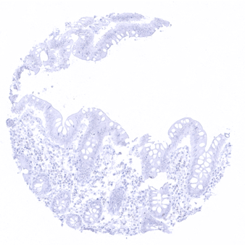
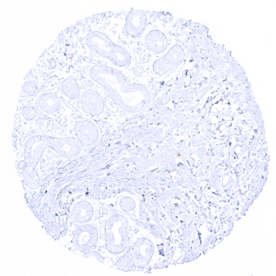
Adrenal gland
Appendix, mucosa
Appendix, muscular wall
Breast

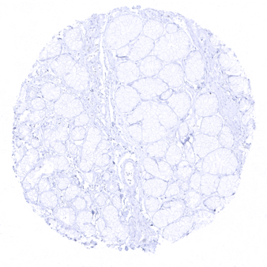
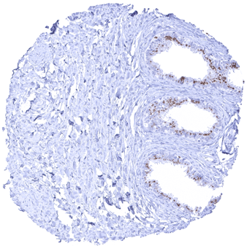
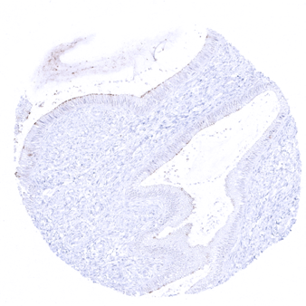
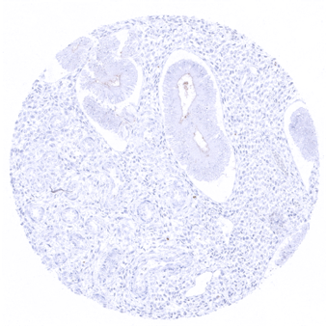
Duodenum, Brunner gland
Endocervix - In endocervical glands, an apical membranous PLAP immunostaining of faint to moderate intensity can occur
Endocervix - In endocervical glands, an apical membranous PLAP immunostaining of faint to moderate intensity can occur
Endometrium, proliferation - In the endometrium, an apical membranous PLAP immunostaining of faint to moderate intensity can occur

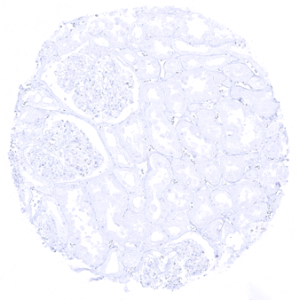
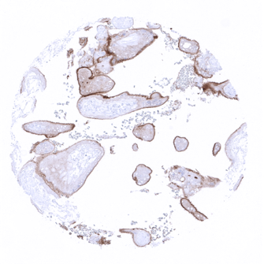
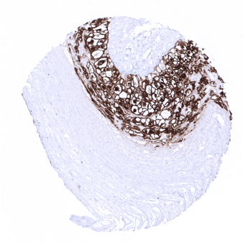
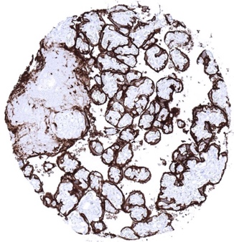
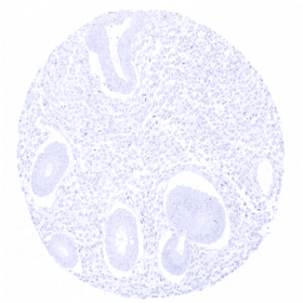
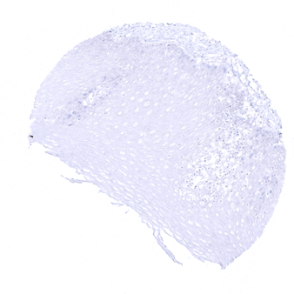
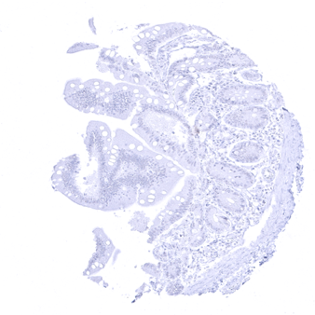
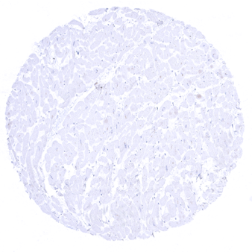
Kidney, cortex
Placenta, early - In the placenta, PLAP immunostaining increases continuously throughout the pregnancy. In the cyto- and syncytiotrophoblast PLAP immunostaining is rather weak in the first trimenon
Placenta, mature - In the placenta, PLAP immunostaining increases continuously throughout the pregnancy. PLAP immunostaining is strong in the cyto- and syncytiotrophoblast of the mature placenta
Placenta, mature, amnion and chorion - In the placenta, membranous PLAP immunostaining is strong in chorion cells
Endometrium, proliferation - PLAP immunostaining is not seen in all endometrium samples
Esophagus, squamous epithelium
Heart
Ileum, mucosa

